Daily Progress Report

Installation / Location | PS-3
Subject | Corrosion Monitoring Activities
Contract Number | LC241047A0
Assigned Petromech Representatives | Shuaib Palakkavalappil
Date of Issue | 23-08-2025

Activities Summary
Work activities commenced today at PS-3, starting with Corrosion Coupon Retrieval at 1 location where reported obstruction in last survey.
ER probe replacement also started late in the afternoon, with 1 locations being serviced where there is scaffolding obstruction reported. Further details of the se locations can be found below.

Time | Activities
06:00 to 09:30 | Proceed to dock ,board vessel to PS-3. Make arrangement for work permit to be issued
09:30 to 11:30 | Commence Coupon Retrievals
11:30 to 12:30 | Lunch
12:30 to 16:00 | Commence ER Probe Replacement
16:30 to 18:00 | Proceed to dock ,board vessel to Halul

Locations Serviced Summary
Tag No | Line Description | Work Completed
53-XCC-909 | 20” Oil Line from MP Separator to V5367 Surge Vessel | Removed 3” Strip Coupons with holder size 10.75”.Replaced 20” Flush disc holder. Replaced all pressure retaining seals
53-XCP-946 | 12” Oil Line from Production Manifold to Test Header | Replaced old ER Probe but steel structure obstructing the retrieval tool gauge, it should replace while perform retrieval activity. 25” RBS Retrieval tool used

Tag No | Line No / Description | Pressure  (psi) | A/F Orientation | Scope of Work | Retrieved Coupons ID /  Holder Length | Coupon Appearance | Installed Coupons ID / Weight / Material | Tool Used | Location Access | Remedial Actions
53-XCC-909 | 20-OC-530266-1144 20” Oil Line from MP Separator to V5367 Surge Vessel | 150 | 12 o Clock | Remove & Replace Corrosion Coupons | MQ031 & MQ032  Holder – 10.25”  Installed on | Dark in colour small number of soft deposits | XR911-17.4135g  20” Flush disc holder  23-08-2025 | 37” | Access Ok. | None Required
Access Fitting Photograph |  |  |  | Retrieved Coupons / Device Photograph |  |  | Installed Coupons / Device Photograph
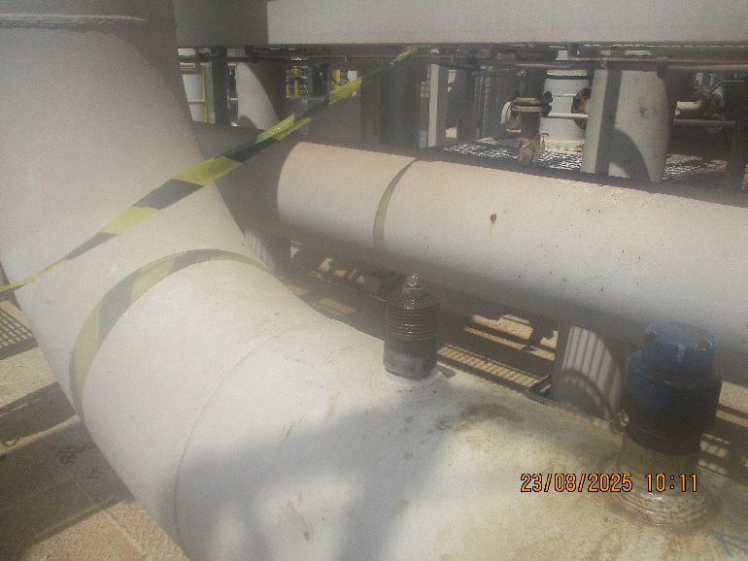 |  |  |  | 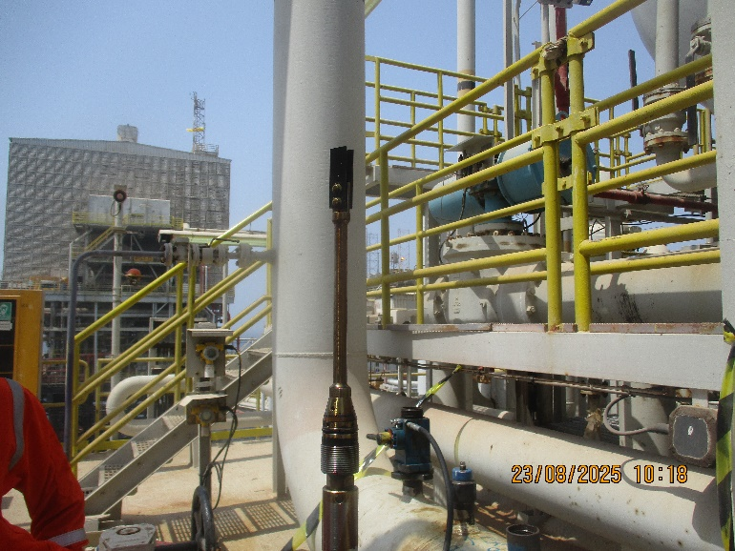 |  |  | 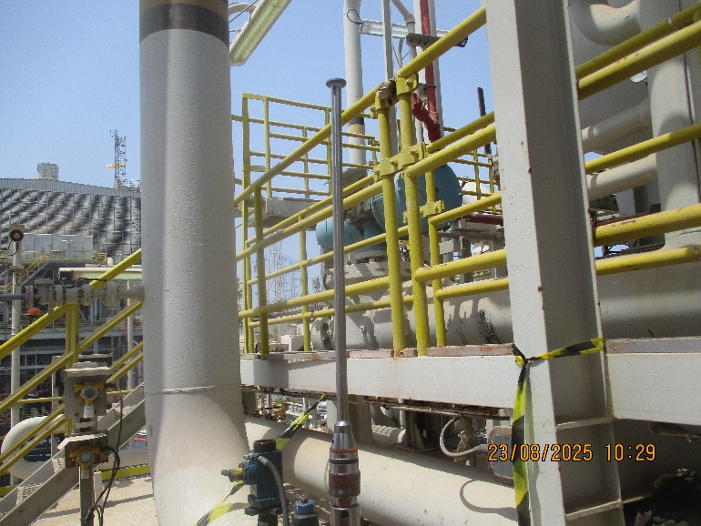
Comments

Tag No | Line No / Description | Pressure  (psi) | A/F Orientation | Scope of Work | Retrieved Probe deatails | Date | New Probe Siz/Specification | Tool Used | Location Access | Remedial Actions
53-XCP-946 | 12-OC-530093-15144X  12” Oil Line from Production Manifold to Test Header | 100 | 12 o Clock | Remove & Replace ER Probe | 4500-T10-K3005-11.25-0-1  Installed date -29-05-2014 | 23-08-2025 | 11.25” size  4705-S8-K03005-11.25-0 | 25” | Access for tool obstructed fitting under grating | Remove the grating while performing the Retrieval
Access Fitting Photograph |  |  |  | Retrieved Coupons / Device Photograph |  |  | Installed Coupons / Device Photograph
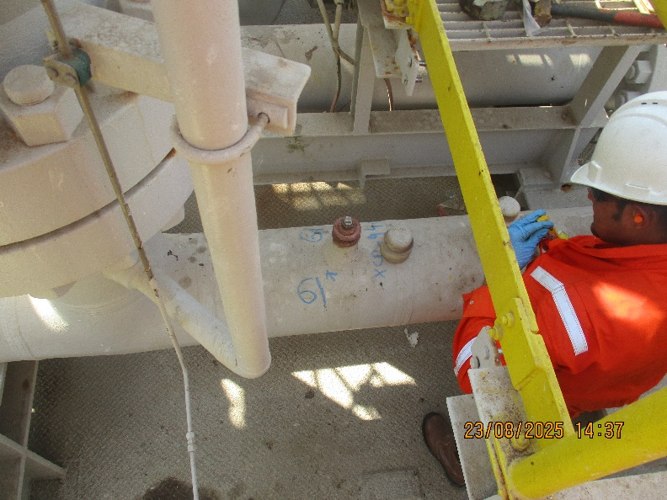 |  |  |  | 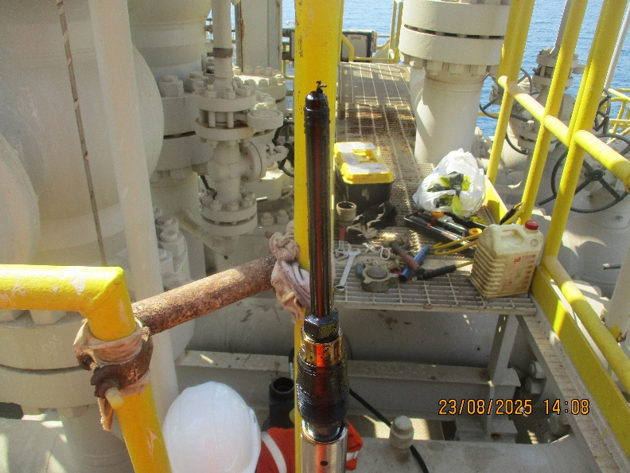 |  |  | 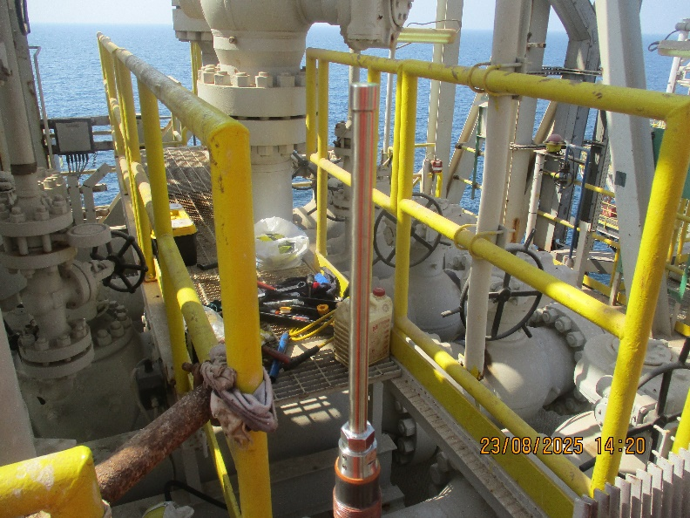
Comments
Replaced old ER Probe but steel structure obstructing the retrieval tool gauge, it should replace while perform retrieval activity. 25” RBS Retrieval tool used

Observations & Recommendations
It was noticed during the ER Probe replacement at the location 53-XCP-946 that the access for tool obstructed by grating, it should remove while performing retrieval and 25” RBS retrieval tool is most suitable for the location

24 Hour Lookahead
The plan for Sunday 24th August is to continue with coupon and probe replacements on PS-3C Platform.

Shuaib Palakkavalappil – Petromech – shuaib.p@petromech.com.qa

